**ToF Sensor Testing**

**1, System setup**

**1.1 Basic facts and experiment material**

Due to the limitation of space, I set up the system in my apartment to test the sensor.[IMG_3443] In Part 2, I discussed how the natural light may influence the system. Basically, sunlight will dramatically increase the noise even with the curtain closed, so most of the test is done in night with light on.

The height of the ceiling is **2.4 m**. While doing the experiment, I moved away all the furniture so that all the reading result was not affected by any other object. The object I used as the target is a box with height of **16 cm**. Then I manually measured the region that the box can be detected by each sensor on the pod and marked it by adhesive tape just as it is shown in the picture:

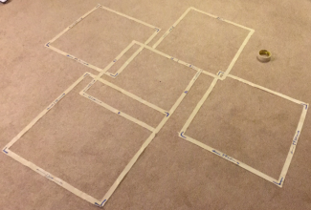

The application of small box to test the detecting region will give us a worst result because the inner boundary of the peripheral sensors will be greatly influenced by the height of the target while the outer bound is independent from that. This may induce difference between the experiment result and the fact when we using the pod with larger spread angle (e.g 30 degrees).

**1.2 Definition of the region boundary**

Since the returning value of the sensor is the distance from the object plus random noise, so we can set a threshold such that when the reading value is below a certain level, we can say something is detected. This boundary condition happens on the edge of the region. That is where the definition of the region boundary comes from.

**2, Test on a single sensor**

In this part, I found out that the enrichment of wave length in natural light can be a important factor that drastically increase the magnitude of noise. A comparison of noise under in-door light and sun light is given as following:

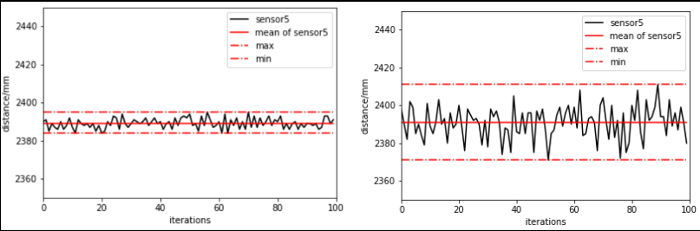

The increase of noise may influence our choice of threshold to decide the boundary, so I did most of the work at night.

**3, Test on single pod with different angle**

**3.1 15 degree pod**

The reading result of 15 degree pod shown below indicates that the sensor at the center will have the smallest reading value for sure, however other sensors may have some differences thought they should have the same distance to the ground in theory. Maybe this is because the pod is not perfectly symmetrical or there is some deviation when sensors are mounted on the pod. This can be ignored as our target is relatively large objects.

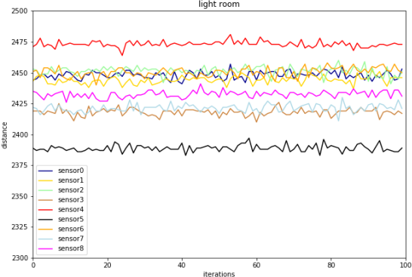

And the testing result of the detection region is shown as:

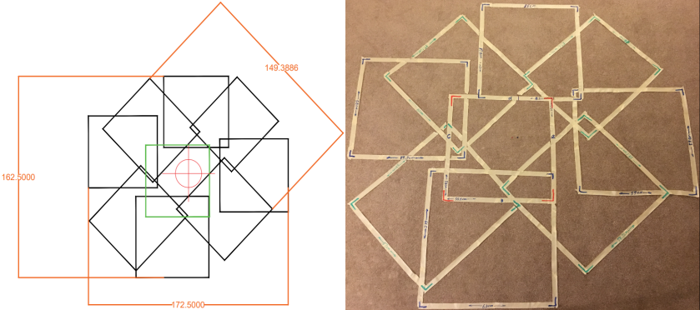

In the CAD version, I marked the center with a red cross and the region of the center sensor with a green square. And regions can be detected by the peripheral sensors are represented by these black squares. All these square have similar dimension that can be approximated by 60 cm * 60 cm. It appears that the total diameter is about **1.5 m**. Again, these regions are not perfectly symmetric.

**3.2 30 degree pod**

The reading result for the 30 degree pod:

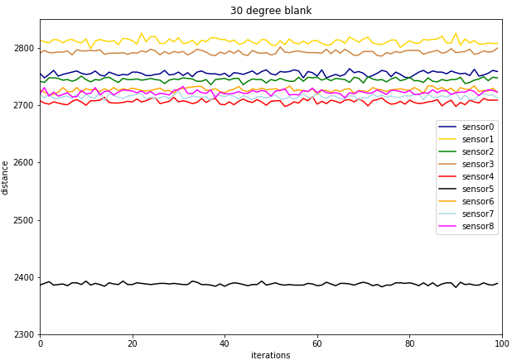

The testing result of the detection region for 30 degree pod is shown as following:

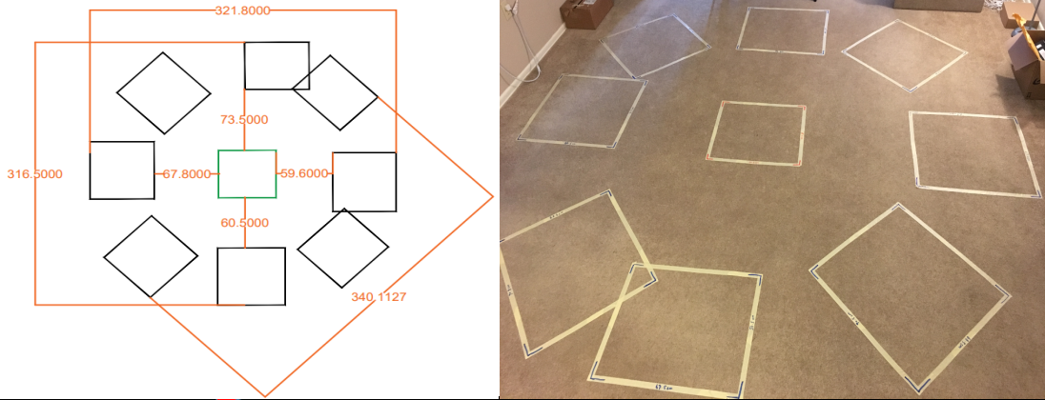

Intuitively, there is a big gap of about 60 cm~70 cm between the center block and surrounding blocks. But if a real people walk in this gap, he will be detected since he is much higher than the box (16 cm). The following graph shows the reading result when I walk in the gap:

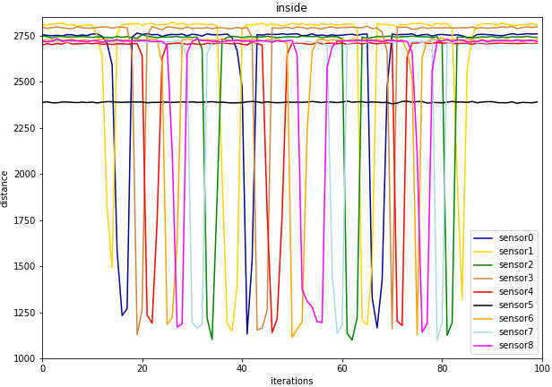

And I made a gif that can be accessed(https://www.dropbox.com/s/32eni9li38hyrvj/inside.gif?dl=0). The gif has 9 pixels, each represent a detection region of a sensor. So this gap may not be a problem for application. Nevertheless, it is a different story for the gap between the peripheral regions. The system will not have any reaction when people standing in these positions. Comparing with the 15-degree pod, this one almost doubled the diameter (about **3.2m**). Similarly, we have the result when I walk in a larger radius:

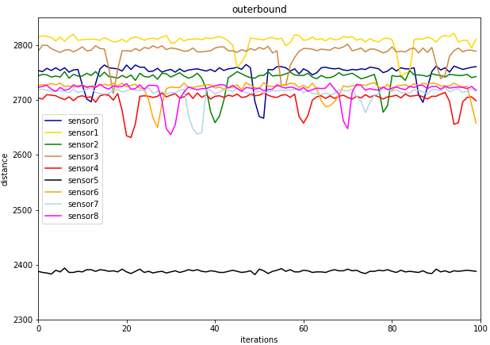

Also there is a gif (https://www.dropbox.com/s/wirzk2hy0fk69un/inblock.gif?dl=0). Comparing with the former one, it is easy to find out that the intensity of this gif is lower since height detected is shorter which is align with the reading result.

**3.3 45 degree pod**

As for the pod with even larger spread angle, I just roughly measure the radius of detection region which is about **2.5 m**. And there is a large gap in between which include some blind regions. But if the target to be detected is moving, these blind points can still be tolerated.

**4, Test on multiple pods**

The most recent work is about how to make multiple pod work together. System synchronization and data transmission are required to achieve this. Currently I tried to make two pods working simultaneously, and the following gif is made to show the testing result. Similar with former tests, I used 18 pixels(3*6) to simplify the 18 different detection regions by each sensor. I didn’t remove any furniture this time. The first scenario is: I sit still in front of the computer, and there is another person come in and walk around the table.

(https://www.dropbox.com/s/paan1jas94csg30/dual.gif?dl=0)

The second scenario is: I sit still at the beginning, when another person stop by, I stand up and walk in the reverse direction around the table. There is a short moment that we stand still closely, then we separate and continue walking.

(https://www.dropbox.com/s/foi2jk3vr2ajxea/Twopersons.gif?dl=0)

In this experiment, we kept a relatively slow walking speed.